ECC Recommendation (05)07

Radio frequency channel arrangements for fixed service systems operating in the bands 71-76 GHz and 81-86 GHz

**approved 15 October 2005**

**latest amended May 2013**

# introduction

The millimetre wave spectrum in the range from 71 to 86 GHz is of major interest to service providers and systems designers because of the favourable propagation, nearly free from O2 absorption attenuation and of the wide bandwidth available for carrying communications. Considering also the possible use of high directional/high gain antennas of relatively small size, these wide bandwidths are valuable in supporting applications such as extremely-high-speed data transmission over significant hop lengths, while offering an inherent reduced interference occurrence probability similar to that experienced in lower FS bands such as the 38 GHz one.

Multiple services and applications can be implemented, with simplified coordination mechanisms, ensuring highly efficient re-use of the frequency band. A simplified coordination mechanism is possible where the link by link coordination, traditionally under the responsibility of the administration, is still required but would be performed by the license holders (i.e. operators). On this subject, ECC Report 80 describes a “light licensing regime” summarised as: *“Light licensing regime, where the position and characteristics of the stations are recorded on a database on a first-come first-served basis, with responsibility for subsequent users to ensure the compatibility with previously notified stations”*.

The choice of the appropriate assignment method and licensing regime remains a decision for national administrations.

The use of the 71-76 GHz and/or 81-86 GHz bands provides the opportunity to cope with the future market demands for increasingly high bandwidth availability, in particular for Internet-based applications and backhaul for 5G and future generation of mobile networks. Fixed radio links may be deployed much quicker and in certain cases are more cost efficient than the wired networks, and as such these bands provide sufficient bandwidth for terrestrial Fixed links to compete or complement the fibre optic-based access networks.

In the proposed scenario of using the 71-76 GHz and/or 81-86 GHz band for Fixed Services, availability objectives in the order of 99.99% with the average European rain rates may be satisfied by very high capacity (up to 10 Gbit/s) links with some 1-2 km hop lengths (line-of-sight conditions); longer hops may be implemented with reduced availability objectives in BCA (Bands and Carrier Aggregation) applications where the combination with lower bands channels, will maintain the highest availability for the priority traffic (see ECC Report 320). The slight attenuation variation between the two bands (71-76 GHz and 81‑86 GHz), makes possible their paired use. These systems would allow a rapid and effective deployment of broadband capacity in areas where fibre optic cables are not available or are not cost-effective.

The main features of operating fixed radio systems in this part of the spectrum may be summed up as follows:

* Availability of wide bandwidths, allowing for the low cost of traffic;
* Possibility of multiple channel frequency re-use, thanks to highly directional antenna beams;
* Feasibility of deploying radio links is much easier in comparison to alternative wire-bound solutions;
* Ability to ensure high security because of low possibility of interference/capture of signals.

The use of the spectrum between 70 to 86 GHz is the viable solution for Fixed links to achieve the above objectives. The lower FS bands at around 50 GHz (28 MHz channels) (ERC/REC12-10) and 52 GHz (28/56 MHz channels) (ERC/REC12-11) have similar propagation conditions but does not provide sufficient space for truly wide band links.

Therefore, the bands 71-76 GHz and 81-86 GHz are considered suitable for the deployment of high speed data FS links.

The ECC Report 124 addresses the compatibility between the FS and passive service in the bands 71-76 GHz and 81-86 GHz and adjacent bands.

It should be noted that the bands 71-76 GHz and 81-86 GHz are used in some countries by other services or applications than FS civil links. This should be taken into account by administrations wishing to use whole or parts of the frequency bands 71-76 GHz and/or 81-86 GHz for civil FS links.

# ECC recommendation of 05(07) on Radio frequency channel arrangements for fixed service systems operating in the bands 71-76 GHz and 81-86 GHz, approved 15 October 2005, revised february 2009, amended may 2013, amended DD MM YYYY

“The European Conference of Postal and Telecommunications Administrations,

*considering*

1. that ITU Radio Regulations (RR) and the ECA allocate the bands 71-76 GHz and 81-86 GHz on a primary basis to Fixed Service as well as other co-primary services;
2. that ITU RR No. 5.340 prohibits all emissions, *inter alia*, in the band 86-92 GHz, and therefore care should be taken to limit the out-of-band emissions from FS in the band 81-86 GHz into the upper adjacent band;
3. that ITU RR No.5.149 applies to the frequency range 76-86 GHz which urges administrations to take all practicable steps to protect the radio astronomy service from harmful interference and further guidance may be found in ECC Report 124;
4. that the band 77-81 GHz has been designated to the SRR (Short Range Radar) equipment in accordance with ECC/DEC/(04)03;
5. that the propagation characteristics of the 71-76 GHz and 81-86 GHz are ideally suited for use of short range FS links in high density networks;
6. that, as the propagation loss difference in the bands 71-76 GHz vs. 81-86 GHz is within the range of 1 dB for the hop lengths of up to 2 km, this also permits using these two bands together for FDD links with large duplex separation;
7. that the FS usage envisaged in this band include digital systems with a variety of modulation schemes, system gains and high data rate capacities over various occupied bandwidths for a range of applications including backhaul for next generation mobile networks;
8. that as an alternative to conventional coordination, a simple form of coordination, similar to that described by ECC Report 80 as “light licensing”, could maintain spectrum efficiency and availability for FS avoiding harmful interference among the users;
9. that ECC/REC/(01)05 provides information for planning of P-P Fixed Service systems;
10. that, in some cases, while maintaining the wide-band oriented use of the band, it might be desirable to allow the use of systems in relatively smaller channel bandwidth;
11. that ETSI has published EN 302 217-2 with characteristics and limits of Point-to-Point equipment in these bands including output power versus antenna gain limitation for improving the interference situation in the network and unwanted emission limitation for the protection of EESS in adjacent 86-92 GHz band;
12. that the ECC Report 124 addresses methodology and emission limits, where appropriate, for the compatibility between the FS in the bands 71-76 GHz and 81-86 GHz with Earth Exploration Satellite Service (EESS) stations operating in the bands 86-92 GHz and Radio Astronomy Service (RAS) stations operating in the bands 76-77.5 GHz and 79-92 GHz
13. that ITU RR Resolution 750 (Rev.WRC-19) provides unwanted emissions at the antenna port of any FS station that should be respected to protect the EESS (passive) in the adjacent 86-92 GHz band.

*recommends*

1. that the use of FS in the 71-76 GHz and 81-86 GHz bands be mainly intended for Point-to-Point (PP) systems[1];
2. that operating frequencies for PP links in these bands be assigned or recorded on a link-by-link basis or with block assignment provided that inter block compatibility is ensured;
3. that administrations wishing to use whole or parts of the frequency bands 71-76 GHz and/or 81-86 GHz for civil FS links and preferring to implement channel arrangement should consider the basic channel arrangements given in ANNEX 1 and ANNEX 2 respectively;
4. that when extremely high bit rate system is required, administrations considering ANNEX 1 or ANNEX 2 may allow flexible aggregation of those 250 MHz basic channels for composing wider channels;
5. that administrations wishing to assign duplex channels, may use the bands 71-76 GHz and 81-86 GHz as paired bands, , as illustrated in ANNEX 3;
6. that administrations wishing to assign pre-defined channels of multiple size, either paired or unpaired, may consider the channel arrangements illustrated in ANNEX 4;
7. that administration wishing to allocate smaller channels, may subdivide those 250 MHz basic channels into multiples 62.5 MHz sub-channels as illustrated in ANNEX 1, ANNEX 2 and ANNEX 4;
8. that administrations who wish to implement a self-coordination mechanism similar to “light licensing” may refer to the example provided in ANNEX 5.”

*Note:*

*Please check the Office documentation database* [*https://docdb.cept.org/*](https://docdb.cept.org/) *for the up to date position on the implementation of this and other ECC Recommendations.*

1. RADIO-FREQUENCY CHANNEL ARRANGEMENTS IN THE BAND 71-76 GHz

Let f*r* be the reference frequency of 71000 MHz,

f*n* be the centre frequency of a radio-frequency channel in the band 71-76 GHz,

n be the channel number,

then the centre frequencies of individual channels with 250 MHz separation are expressed by the following relationship:

f*n* = f*r* + 250·n MHz

where:

* n = 1, 2, 3, ..., 19

Note, that the specified channels may be used to form either TDD or FDD systems within the single band, or in combination with other band specified in this recommendation.

A number of contiguous individual channels with 250 MHz separation maybe further subdivided into 62.5 or 125 MHz channels.

* 1. Calculated parameters according to ITU-R Rec. 746

**Table 1: Channel arrangements in the band 71-76 GHz**

|  |  |  |  |  |  |
| --- | --- | --- | --- | --- | --- |
| **XS**  **MHz** | **n** | **f1**  **MHz** | **fn**  **MHz** | **Z1S**  **MHz** | **Z2S**  **MHz** |
| 250 | 1,...19 | 71250 | 75750 | 250 | 250 |

XS Separation between centre frequencies of adjacent channels

Z1S Separation between the lower band edge and the centre frequency of the first channel

Z2S Separation between centre frequencies of the final channel and the upper band edge

1. RADIO-FREQUENCY CHANNEL ARRANGEMENTS IN THE BAND 81-86 GHz

Let f*r* be the reference frequency of 81000 MHz,

f*n* be the centre frequency of a radio-frequency channel in the band 81-86 GHz,

n be the channel number,

then the centre frequencies of individual channels with 250 MHz separation are expressed by the following relationship:

*fn* = *fr* + 250·n MHz

where:

n = 1, 2, 3, ..., 19

Note, that the specified channels may be used to form either TDD or FDD systems within the single band, or in combination with other band specified in this recommendation.

A number of contiguous individual channels with 250 MHz separation maybe further subdivided into 62.5 or 125 MHz channels.

* 1. Calculated parameters according to ITU-R Rec. 746

Table 2: Channel arrangements in the band 81-86 GHz

|  |  |  |  |  |  |
| --- | --- | --- | --- | --- | --- |
| **XS**  **MHz** | **n** | **f1**  **MHz** | **fn**  **MHz** | **Z1S**  **MHz** | **Z2S**  **MHz** |
| 250 | 1,...19 | 81250 | 85750 | 250 | 250 |

XS Separation between centre frequencies of adjacent channels

Z1S Separation between the lower band edge and the centre frequency of the first channel

Z2S Separation between centre frequencies of the final channel and the upper band edge

1. examples of pairing and aggregating channels in the frequency bands 71-76 / 81-86 ghz

The principle of using the channels from within the bands 71-76 GHz and 81-86 GHz in a single duplex FDD arrangement is described in Figure 1.

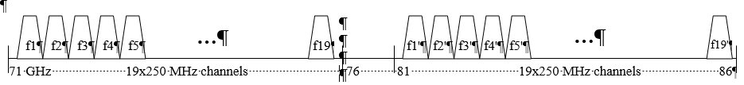

Figure 1: Combining the channels from 71-76 / 81-86 GHz bands into a single FDD arrangement with duplex separation of 10 GHz



When the wider channels are needed then a flexible number of consecutive 250 MHz channels may be aggregated into FDD channels, as illustrated in Figure 2, for duplex separation equal to 10 GHz. Administrations that prefer to use of multiple sizes channels in predefined positions may refer to ANNEX 4.

f1 (1.25 GHz)

f2

**…**

**…**

f2'

*fi'*'

71 GHz 76 81 86

f*i*

f1' (1.25 GHz)

Figure 2: Example of aggregating multiple 250 MHz channels, possibly alongside with original 250 MHz wide channels

When channels smaller than 250 MHz are desired, the subdivision of one or more contiguous individual 250 MHz channels is possible following ANNEX 4.

1. channel Arrangements for Multiple size TDD/FDD AGGREGATed CHANNELS IN FREQUENCY BANDS 71-76 / 81-86 GHz
2. A multiple sizes channel arrangement for these bands depends on the basic assumptions that an administration makes for the deployment, e.g.:

TDD, FDD or their mixed use of the band;

Paired FDD assignments with fixed duplex;

FDD channels paired either in each single band or in cross-band pairing, or both contemporarily.

1. Basic channels arrangements are made by the continuous raster of individual 250 MHz channels described in ANNEX 3;
2. Channels of larger size are obtained through aggregation of individual 250 MHz channels according the arrangements shown in:   
     
   Figure3 applicable, for what concerns FDD systems, when the bands 71-76 GHz and 81-86 GHz are jointly used providing paired channels bandwidths from 250 MHz to 4 500 MHz with duplex spacing 10 GHz (see note).   
   Figure 4 applicable, for what concerns FDD systems, as alternative to Figure3, when the smaller channels, residual of larger channels arrangements are concentrated in the upper parts of the paired bands facilitating, when necessary, compatibility/segmentation among FDD/TDD or PP/PMP applications   
   Figure 5 applicable, for what concerns FDD systems, when the bands 74-76 GHz and 84-86 GHz are jointly used providing paired channels bandwidths from 250 MHz to 1750 MHz with duplex spacing 10 GHz.
3. When desirable for accommodating smaller channels, administrations may provide a number of channel bandwidths of 62.5 MHz and 125 MHz by subdividing one or more 250 MHz channel. Figure 6 shows an example of an actual arrangement.

Note: This arrangement in Figure 3 was intended for compatibility to older (and no longer recommended) single bands FDD arrangements with Duplex separation of 2.5 GHz; therefore, it is not preferred for new networks deployments. The contoured zone in Figure 3 represents the portion of channel arrangement differing from that of Figure 4.

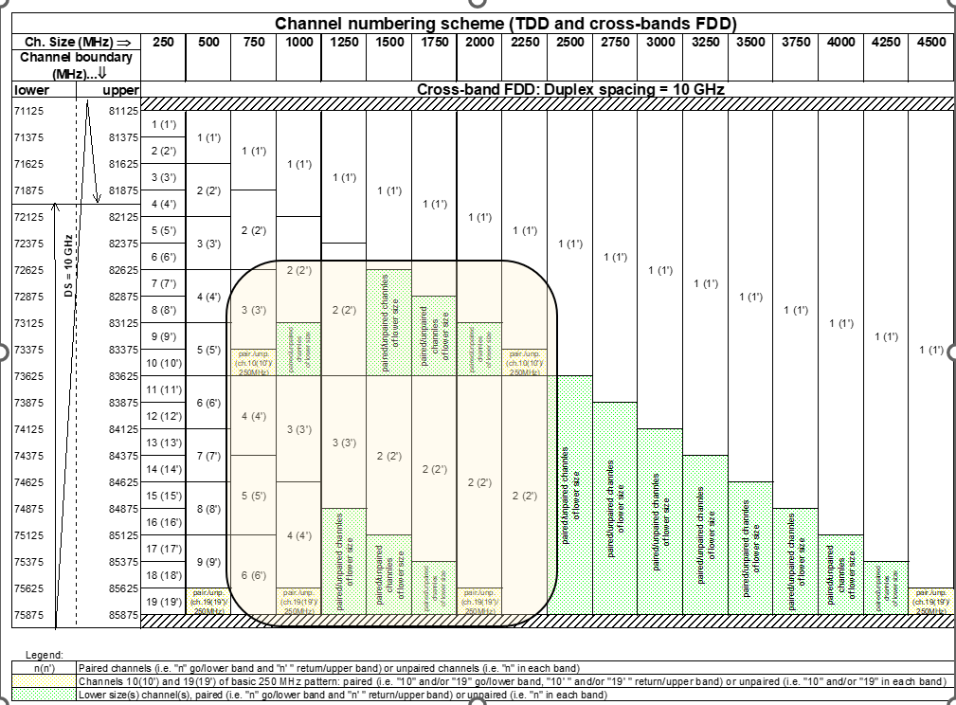

Figure 3: Channel positions for TDD and FDD applications



Figure 4: Channel positions for TDD and FDD applications

**Figure 5: Channel positions for TDD and cross-bands FDD applications**

**(Limited to 74-76 GHz and 84-86 GHz bands)**



**Figure 6: Example of subdivision of contiguous 250 MHz individual channels into 62.5 MHz and 125 MHz channels**

Note: This example is tailored for the numbering scheme of the uppermost 250 MHz individual channels (including the special case of the unpaired channel 10 in the channel arrangement of Figure 3). The numbering scheme for the actually desired set of contiguous 250 MHz individual channels may be similarly derived

1. EXAMPLE OF TECHNICAL BACKGROUND FOR IMPLEMENTING A SELF-COORDINATION APPROACH FOR PP FS (INCLUDING FLANE)

To assist the planning of PP Fixed links, self-coordination approach, similar to the “light licensing”, described in ECC Report 80, can be considered. Such regimes do not mean “licence exempt” use, but rather using a simplified set of conventional licensing mechanisms and attributes within the scope decided by administration. This planning is delegated to the licensee.

Administrations intervene for protecting a limited number of sensitive sites while giving greater flexibility elsewhere than it could be allowed without the geographical limitation.

This process requires to record for instance the following set of simple criteria for each authorised link and makes the data available publicly to assist in the identification of operational parameters and to conduct interference analyses:

* Date of application (In order to assign priority);
* Transmit, receive centre frequencies and occupied bandwidth;
* Equipment type, specifying relevant transmitter/receiver parameters;
* Link location (geographic coordinates, height/direction of antenna, etc…);
* The antenna gain and radiation pattern.

Subject to the conditions set by the administration, it is left to the operator to conduct any compatibility studies or coordinate as necessary to ensure that harmful interference is not caused to existing links registered in the database keeping that analysis available for any dispute resolution. For example, an operator wishing to install a new link could calculate the interference that the new link will create to the existing links in the database. Then it will be possible to determine whether this new link will interfere with existing links. If so, the new link could be re-planned to meet the interference requirements of existing links in the database. Otherwise, the new link may be also co-ordinated with existing operators, who might suffer from the interference.

To assist with the resolution of disputes, licences are issued with a “date of priority”: interference complaints between licensees may therefore be resolved on the basis of these dates of priority (as with international assignments). Consideration of a maximum time frame between the link registration and its effective operational start is a matter for administrations at national level.

.

1. **LIST OF REFENCES**
2. ’to be prepared during public consultation

1. This recommendation was written with the spirit of addressing PP system. Administrations wishing to use also PMP applications within these bands should assess further the applicability of this recommendation to PMP systems.