Project Team FM22
CG on “Field strength measurements at the border”
Date issued: | 26 July 2023
Source: | Lithuania
Subject: | Field strength for systems using MIMO with cross-polarized antennas
Group membership required to read? (Y/N) |  | N
Summary:
This document provides elements when considering fields strength measurements for the systems using MIMO with cross-polarized antennas.
Proposal:
To include provided material into new ECC Recommendation on field strength measurements.
Background:
Work item FM22_37 - Common measurement method for MFCN in border areas
FM22(22)06_Lithuania - Practical supervision of MFCN field strength in border areas
FM22(22)49_Lithuania - Supervision of MFCN field strength in border areas
FM22(23)12_Lithuania - Issues of MFCN field strength control in border areas

Field strength of overlapping electromagnetic fields
This section describes the procedure for calculating the resulting field strength when several electromagnetic waves with collinear field strength vectors overlap in space. Let us first consider the situation when at some point in space two transmitting different signals antennas individually produce field strengths E_{A} and E_{B}. In the general case, the amplitudes of these field strengths are random variables. Let that the amplitude of the first field strength be equal to A and variance be equal σ²(A), and the second - B and σ²(B) respectively. As is known, the variance of the sum of two random variables is
 | $$σ^{2}(A+B)=σ^{2}\left(A\right)+σ^{2}\left(B\right)+2Cor(A+B)$$ | (1)
The correlation Cor(A+B) is related to the correlation coefficient R(A,B) by the following expression
 | $$Cor\left(A+B\right)=R\left(A,B\right)\sqrt{σ^{2}(A)σ^{2}(B)}$$ | (2)
Therefore, expression (1) can be written in the following form
 | $$σ^{2}(A+B)=σ^{2}\left(A\right)+σ^{2}\left(B\right)+2R(A,B)×\sqrt{σ^{2}(A)σ^{2}(B)}$$ | (3)
Taking the root of the right and left parts, expression (3) is reduced to the form
 | $$σ\left(A+B\right)=\sqrt{σ\left(A\right)+σ\left(B\right)+2R(A,B)σ(A)σ(B)}$$ | (4)
For electromagnetic waves the average values of the amplitudes of field strength are equal to zero. Therefore, the standard deviation σ of the amplitude of field strength is equal to the root-mean-square (rms) value of their amplitude.
The field strength of electromagnetic waves is usually characterized by the rms value, so expression (4) can be written in the following form
 | $$E(A+B)=\sqrt{E_{A}^{2}+E_{B}^{2}+2R(A,B)E_{A}E_{B}}$$ | (5)
The correlation coefficient between wave amplitudes R(A,B) (hereinafter referred to as R) is usually equal to or slightly different from the correlation coefficient between the transmitted signals that "carry" these waves. It should be noted that the field strengths are vector quantities. Therefore, when adding waves with parallel field strength vectors, the resulting field strength E_{RES} is equal to
 | $$E_{RES}=\sqrt{E_{A}^{2}+E_{B}^{2}+2RE_{A}E_{B}}$$ | (6)
and when adding waves with antiparallel ones, is equal to
 | $$E_{RES}=\sqrt{E_{A}^{2}+E_{B}^{2}-2RE_{A}E_{B}}$$ | (7)
It should be noted that expressions (6) and (7) are valid only for the rms values of the field strength.
Let us consider in more detail how the strengths of two overlapping in space waves add up when vectors $\vec{Е_{A}}$ and $\vec{Е_{B}}$ are parallel. If the transmitted signals are perfectly correlated (R=1), then, as follows from equation (6), the resulting field strength is equal to
 | $$E_{RES}=E_{A}+E_{B}$$ | (8)
and if they are completely uncorrelated (R=0), the resulting field strength is equal to
$$E_{RES}=\sqrt{E_{A}^{2}+E_{B}^{2}}$$ | (9)
Similarly, one can obtain an expression for the resulting field strength when N antennas of the same polarization individually produce field strengths E₁, E₂...E_{N}. If any transmitting signals are perfectly correlated with each other, the resulting field strength is equal to
$$E_{RES}=\sum_{i=1}^{N}{E_{i}}$$ | (10)
and if they are completely uncorrelated with each other, the resulting field strength is equal to
$$E_{RES}=\sqrt{\sum_{i=1}^{N}{E_{i}^{2}}}$$ | (11)

Field strength of the system using cross-polarized antennas
This section will look into the properties of the fields produced by antenna array without beamforming, as they are widely used in LTE networks. As a rule, these arrays are a combination of two or more cross-polarized (orthogonal) individual antennas. The individual antennas themselves are assembled from a large number of dual-polarized elements. Figure 1 shows that simplest array and more complex array. Dual-polarized array consist of two antenna columns: one with radiating elements with the polarization of +45 degrees, and the second with radiating elements with the polarization of -45 degrees (to be more correct the polarization actually is +135 degrees rather than -45 degrees).
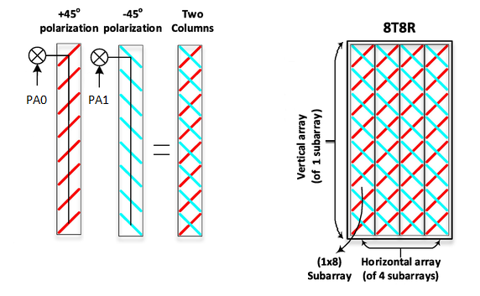
Figure 1: left – the simplest array (consisting of two cross-polarized antennas), right – an array of eight cross-polarized antennas
Each physical antenna has individual RF chain (also known as antenna port). The first antenna PA0 (corresponds to the antenna port AP0) consists of radiating elements with a polarization of +45 degrees, the second antenna PA1 (corresponds to the antenna port AP1) consist of radiating elements with a polarization of +135 degrees. This antenna array can be used for 2xMIMO (2T2R) technology. More complex antenna array is a combination of subarrays. One subarray includes only antennas with a polarization of +45 degrees and +135 degrees.
From the above it is clear that the waves emitted by antenna arrays with cross-polarized antennas are slant polarized where each wave is rotated 45 degrees from the horizontal, mirrored, so the first is at +45 degrees and the other is at +135 degrees, as shown in Figure 2.
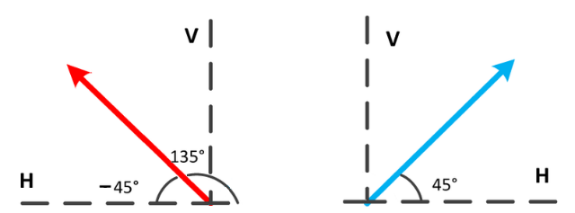
Figure 2: slant 45° dual‐pol mode
Each of these two waves is characterized by its field strength at the measurement point E(45) and E(135). In the case of the simplest antenna array, the field strength E(45) is created by antenna PA0, and the field strength E(135) by antenna PA1.
In the case of array that consists of four antennas (4T4R), each antenna PA0, PA1, PA2 and PA3 individually produce field strengths E₀(45), E₁(45), E₂(135) and E₃(135) respectively. In this case, the field strength E(45) is the result of adding the field strengths E₀(45) and E₁(45) according to equation (6) (because vectors $\vec{Е_{0}(45)}$ and $\vec{Е_{1}(45)}$ are parallel), and the field strength E(135) is the result of adding the field strengths E₂(135) and E₃(135) according to the same equation. According to this equation, the resulting field strengths E(45) and E(135) depend on the correlation coefficient between the signals transmitted by antennas PA0 and PA1 and between PA2 and PA3 respectively. This dependence is described in detail in Section 1.

Measuring field strength of cross-polarized waves
As follows from Section 2, in the case of cross-polarized fields, two field strengths E(45) and E(135) must be measured. In principle, this is easy to do using a linearly polarized measuring antenna and a conventional spectrum analyser. Since this is not always convenient in practice, instead of measuring two individual field strengths, the vertical component E(V) of the resulting field strength of the two waves is measured (using a measuring antenna with vertical polarization).
This section will analyse how this vertical component E(V) depends on the individual field strengths E(45) and E(135). Figure 3 shows the vertical and horizontal projections of these field strength vectors.
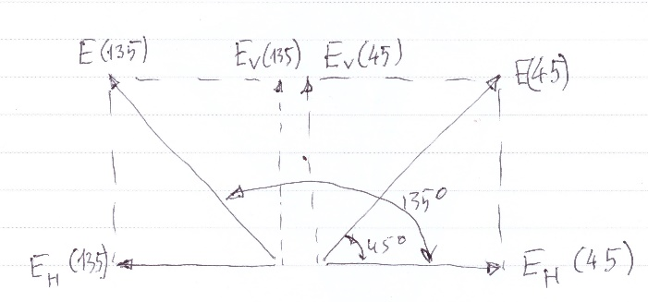
Figure 3: Decomposition of two perpendicular field strength vectors (E(45) and E(135)) into vertical and horizontal components
Let us consider the result of the case when the fields strengths E(45) and E(135) are equal (let's denote them as E).
The vertical and horizontal components of individual field strengths E(45) and E(135) are:
 | $$E_{V}\left(45\right)=E_{H}(45)=E(45)sin45°$$ | (12a)
 | $$E_{V}\left(135\right)=E_{H}(135)=E(135)sin45°$$ | (12b)
For the two parallel vertical components the sum E(V) depends on correlation coefficient R according to equation (6). For the two antiparallel horizontal components the sum E(H) also depends on correlation coefficient R according to equation (7).
If correlation coefficient R = 1, i.e. perfectly correlated vertical components, then according to equation (6) the sum E(V) is
 | $$E\left(V\right)=E×sin45°+E×sin45°=2E×sin45°$$ | (13)
From this expression it is easy to get that the sum E(V) is higher by 3 dB:
 | $$20log\frac{E\left(V\right)}{E}=20log\frac{2Esin45°}{E}=20\log\left(2sin45°\right)=3 dB$$ | (14)
If correlation coefficient R = 0, i.e. the vertical components are completely uncorrelated, then according to equation (6) the sum E(V) is equal to individual field strength (with a polarization of 45 degrees or 135 degrees):
 | $$E\left(V\right)=\sqrt{{(E×sin45°)}^{2}+{(E×sin45°)}^{2}}=E\sqrt{2\sin^{2}45°}=E$$ | (15)
Thus, depending on the degree of correlation (coefficient R), the field strength of vertical component is equal or 3 dB higher than the field strength of individual field strength (with a polarization of +45 degrees or +135 degrees).
For the two horizontal components E_{H}(45) and E_{H}(135) the sum E(H) depends on correlation coefficient R according to equation (7).
If correlation coefficient R = 1, i.e. perfectly correlated horizonal components, then according to equation (7) the sum E(H) is equal to 0:
 | $$E\left(H\right)=E×sin45°-E×sin45°=0$$ | (16)
If correlation coefficient R = 0, i.e. the horizontal components are completely uncorrelated, , then according to equation (7) the sum E(H) is equal to individual field strength (with a polarization of +45 degrees or +135 degrees):
 | $$E\left(H\right)=\sqrt{{(E×sin45°)}^{2}+{(E×sin45°)}^{2}}=E\sqrt{2\sin^{2}45°}=E$$ | (17)
In general for MIMO systems it can be assumed that signals between individual antennas are uncorrelated, and all antennas create fields with equal average field strengths. Therefore, it can be concluded that measuring with vertical polarized antenna the average values of the resulting field strength in the vertical plane is equal to the average value of the individual field strength in the +45 degrees or +135 degrees planes. The same result is obtained when measuring with horizontally polarized antenna.

Field strength derivation when measuring reference signal received power (RSRP) for LTE MIMO system
For LTE dedicated reference signals are assigned for all the antenna ports individually. Using a specialised equipment (radio scanner) the reference signal received power (RSRP) is measured for each physical antenna. It is the power of the LTE reference signals spread over the full bandwidth and narrowband.
Since RSRP is transmitted on one reference signal which allocates one sub-carrier (or resource element) there is a need to extrapolate to a full traffic situation. The number of sub-carriers in the LTE traffic signal depends on transmitted signal bandwidth. Extrapolation to a full traffic situation can be calculated with the following formula:
 | $$P_{tot}^{i}={RSRP}^{i}+10log(n)$$ | (18)
where
- $P_{tot}^{i}$ is the total LTE signal received power level produced by i^{th} transmitting antenna extrapolated to a full traffic situation in dBm;
- n is the number of subcarriers in the relevant LTE signal.
For 2xMIMO (2T2R) the RSRP-0 and RSRP-1 are measured. It should be noted that when measuring RSRP-0, the polarization of the measuring antenna should be equal to +45 degrees, and when measuring RSRP-1 should be +135 degrees. Using these values the field strengths $E_{tot}^{0}$ and $E_{tot}^{1}$ are calculated.
For 4xMIMO (4T4R) the RSRP-0, RSRP-1, RSRP-2 and RSRP-3 are measured and using these values the field strengths $E_{tot}^{0}, E_{tot}^{1}, E_{tot}^{2}$ and $E_{tot}^{3}$ are calculated. To get the resulting total field strength in the +45 degrees plane, there is a need to add the field strengths $E_{tot}^{0}$ and $E_{tot}^{1}$. Similarly, the resulting total field strength in the +135 degrees plane is obtained by adding the field strengths $E_{tot}^{2}$ and $E_{tot}^{3}$. The procedure for calculating the resulting field strength is described in detail in Section 1.
The relation between the measured power in dBm and the field strength in dBµV/m is given by the frequency and the receiver’s parameters according to the following equation:
 | $$E\left(\frac{dBμV}{m}\right)=Z(dB)+P_{R}\left(dBm\right)-20\lg\left(\frac{300}{f\left(MHz\right)}\right)+20lg⁡\left( 2π×\sqrt{\frac{73}{R(Ω)}}\right)-GP(dB)+loss(dB)$$ | (19)
where
- E is field strength received in dBµV/m;
- Z is referring to impedance in dB (for 50 Ω impedance Z = 107 dB, for 75 Ω impedance Z = 108.75 dB);
- P_{R} is power received in dBm;
- f is frequency in MHz;
- R is impedance in Ω (50 Ω or 75 Ω);
- GP is antenna gain in dB calculated as GP=G-2.15+reference_antenna_gain, where G is receiving antenna gain in dB and reference antenna gain: short vertical = 4.8 dB, half wave = 2.15 dB, isotropic = 0 dB);
- loss is receiver losses in dB.
For example, normally receiver input impedance is 50 Ω, reference antenna is isotropic and assuming that receiver losses are 0 dB, the equation (19) becomes
 | $$E\left(\frac{dBμV}{m}\right)=P_{R}\left(dBm\right)+77.2 (dB)-G(dBi)+20\lg\left(f\left(MHz\right)\right)$$ | (20)

